**Answers 3.7**

1. **Write a query to find the top 10 countries for Rockbuster in terms of customer numbers. (Tip: you'll have to use GROUP BY and ORDER BY, both of which follow the join.)**
   * **Copy-paste your query and its output into your answers document.**

SELECT D.country,

COUNT(customer_id) AS customers

FROM customer A

INNER JOIN address B ON A.address_id = B.address_id

INNER JOIN city C ON B.city_id = C.city_id

INNER JOIN country D ON C.country_ID = D.country_ID

GROUP BY country

ORDER BY customers DESC

LIMIT 10

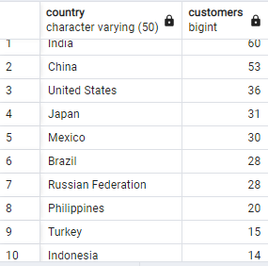

* + **Write a few sentences on how you approached this query and why. It's important that you can explain your thought process when writing queries, especially for future interviews.**

First, I select country. Then have the query count the number of customers and named this “customers” with AS. I then had to find a key for the query between country and customer. Since there isn’t one, I had to use tables that connect these two together, namely: address and city. I used the INNER JOIN function for this because I want limited information. Then, I had to group this query by countries and put them in descending order with a limit of 10.

1. **Write a query to find the top 10 cities within the top 10 countries identified in step 1.**
   * Copy-paste your query and its output into your answers document.

SELECT C.city, D.country,

COUNT(customer_id) AS customers

FROM customer A

INNER JOIN address B ON A.address_id = B.address_id

INNER JOIN city C ON B.city_id = C.city_id

INNER JOIN country D ON C.country_ID = D.country_ID

WHERE country IN('India', 'China', 'United States','Japan',

'Mexico','Brazil','Russian Federation',

'Philippines','Turkey','Indonesia')

GROUP BY city, country

ORDER BY customers DESC

LIMIT 10

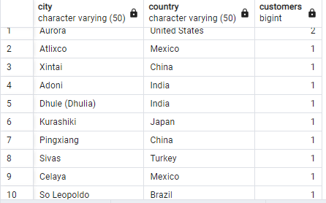

* + Write a short explanation of how you approached this query and why.

This is the same function as the one from question 1 but I factored in the cities.

1. Write a query to find the top 5 customers in the top 10 cities who have paid the highest total amounts to Rockbuster. The customer team would like to reward them for their loyalty!
   * Tip: After the join syntax, you’ll need to use the WHERE clause with an operator, followed by GROUP BY and ORDER BY. Your output should include the following columns: Customer ID, Customer First Name and Last Name, Country, City, Total Amount Paid.

SELECT

B.customer_id,

B.first_name,

B.last_name,

D.city,

E.country,

SUM(A.amount) AS total_amount_paid

FROM payment A

INNER JOIN customer B ON A.customer_id = B.customer_id

INNER JOIN address C ON B.address_id = C.address_id

INNER JOIN city D ON C.city_id = D.city_id

INNER JOIN country E ON D.country_ID = E.country_ID

WHERE city IN('Aurora', 'Atlixco', 'Xintai', 'Adoni', 'Dhule (Dhulia)', 'Kurashiki', 'Pingxiang', 'Sivas', 'Celaya', 'So Leopoldo')

GROUP BY B.customer_id, B.first_name, B.last_name, D.city, E.country

ORDER BY total_amount_paid DESC

LIMIT 5

